**Case Study**

**- Integration of DevOps Tools**

**with Jenkins**

**Problem Statement:**

You have been hired as a DevOps Engineer in XYZ software company. They

want to implement CI/CD pipeline in their company. You have been asked to

implement this lifecycle as fast as possible. As this is a product-based company,

their product is available on this GitHub link. https://github.com/hshar/website.git

Following are the specifications of the continuous integration:

1. Git workflow has to be implemented

2. CodeBuild should automatically be triggered once a commit is made to

master branch or develop branch. If a commit is made to master branch,

build and publish a website on port 82. If a commit is made to develop a

branch, just build the product, do not publish.

3. Create a pipeline for the above tasks

4. Create a container with Ubuntu and Apache installed in it and use that

container to build the code and the code should be on ‘/var/www/html’.

Sol:

* Created 2 instances, Jenkins Master and the Node2

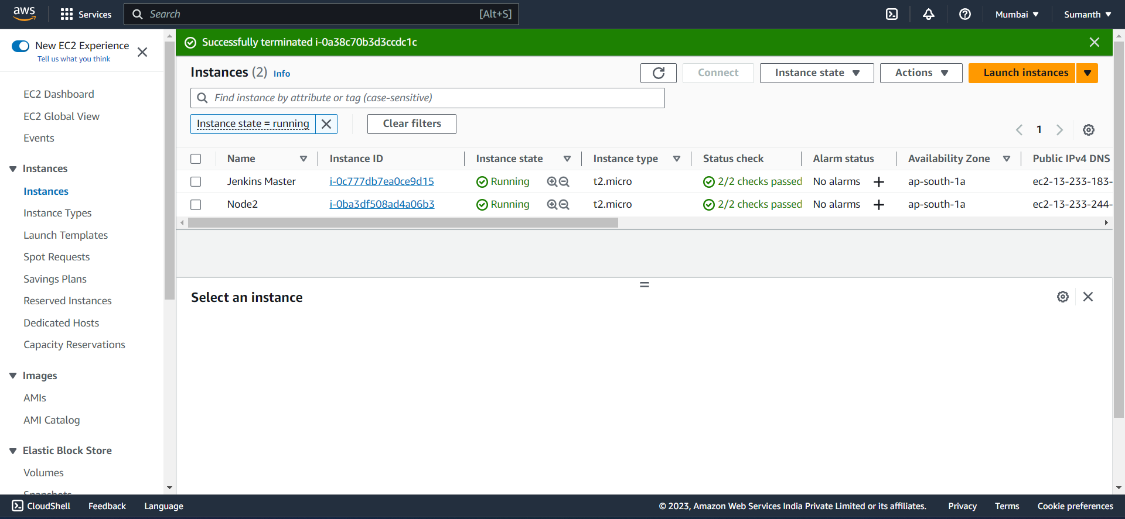

* Connected my Node2 with Jenkins Master ( Make sure to install Java in Node2 for connecting with Master ).

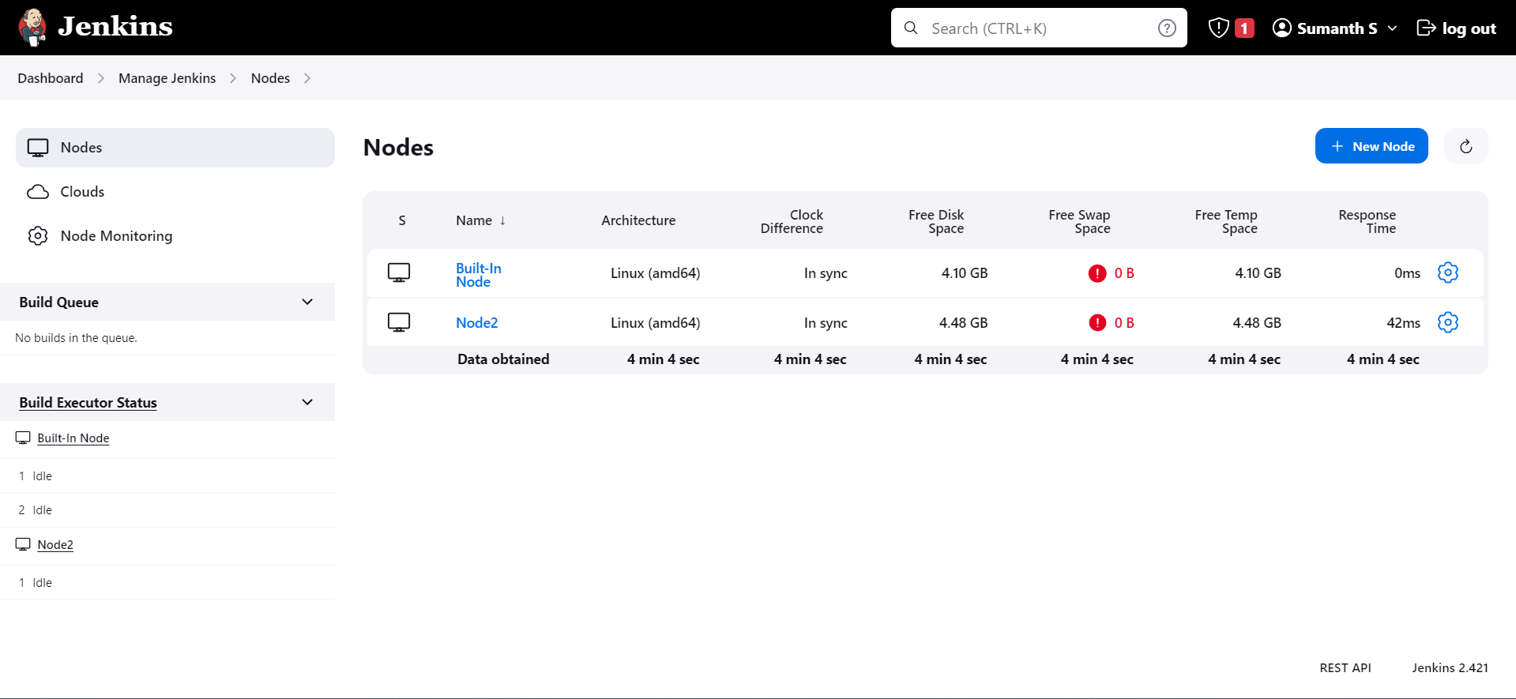

* Forked the Github repo, cloned that on my repo and also created a Dockerfile. ( also install docker in Node2).

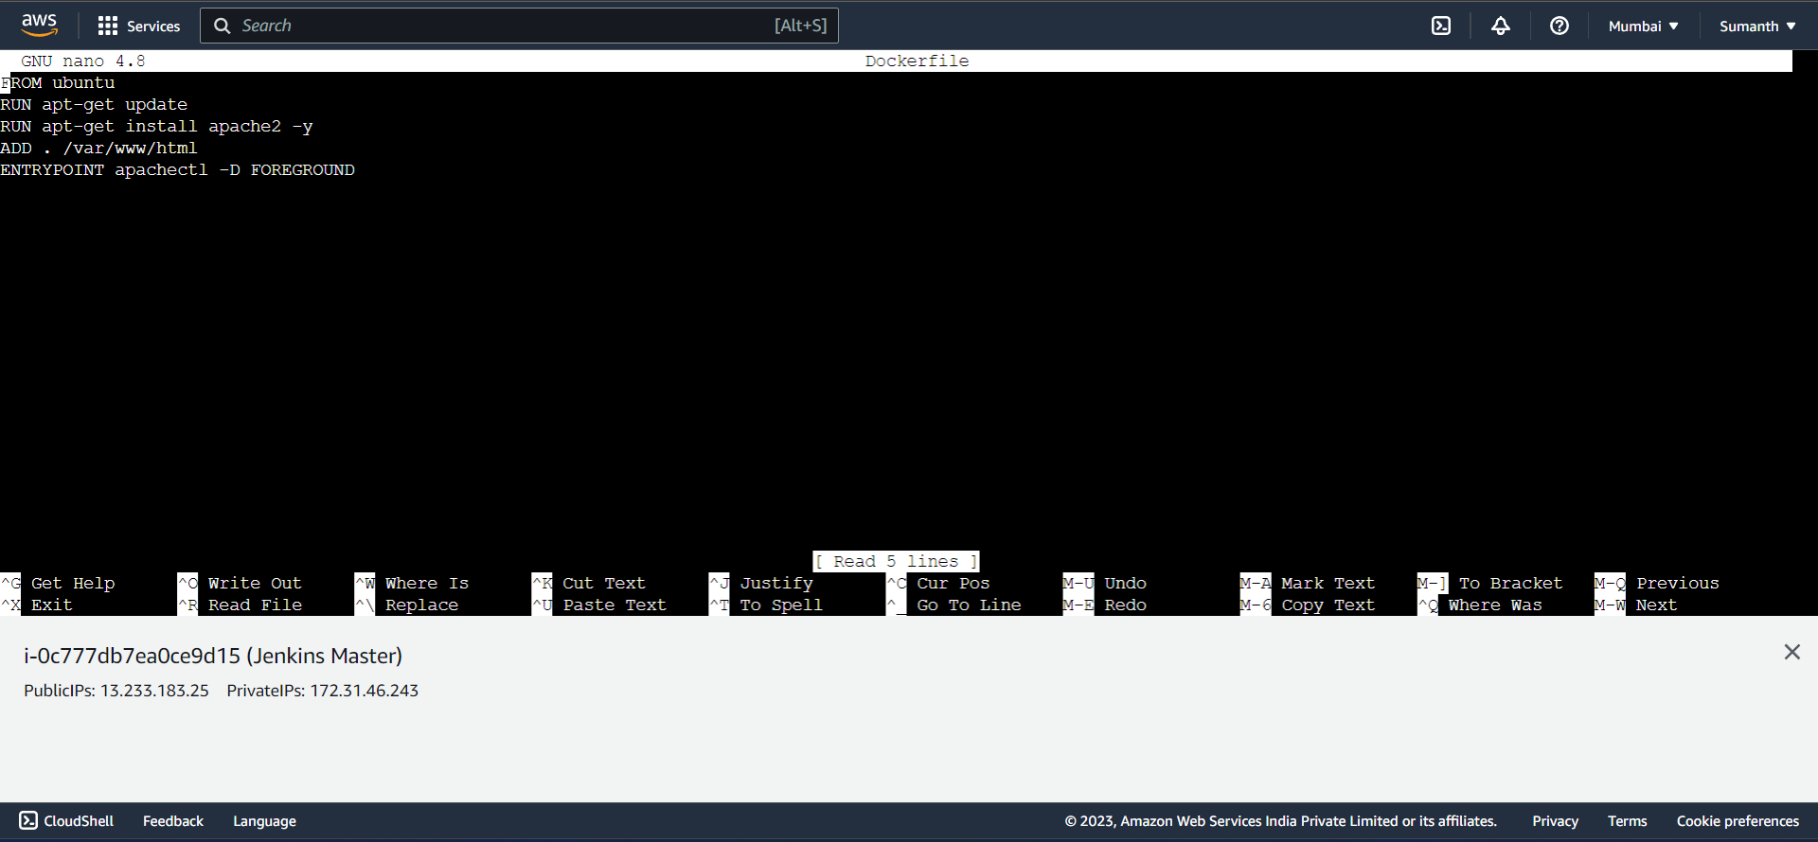

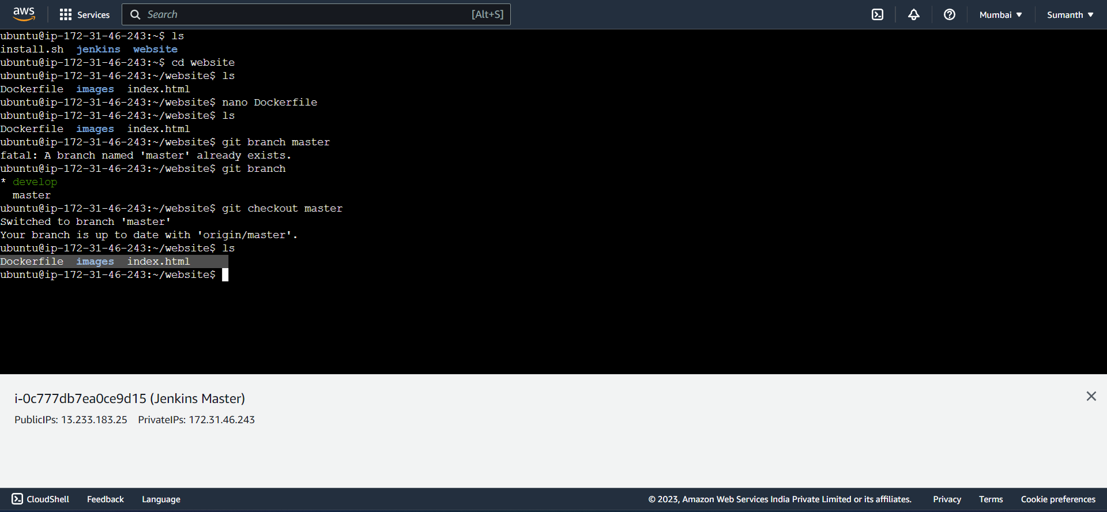

* Created 2 Jobs for Master branch and Develop branch

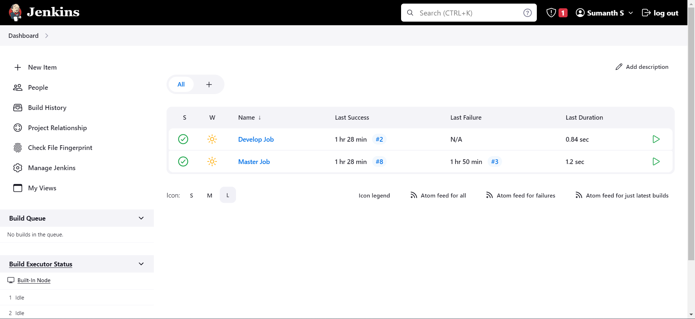

* Created webhook to automate build and test

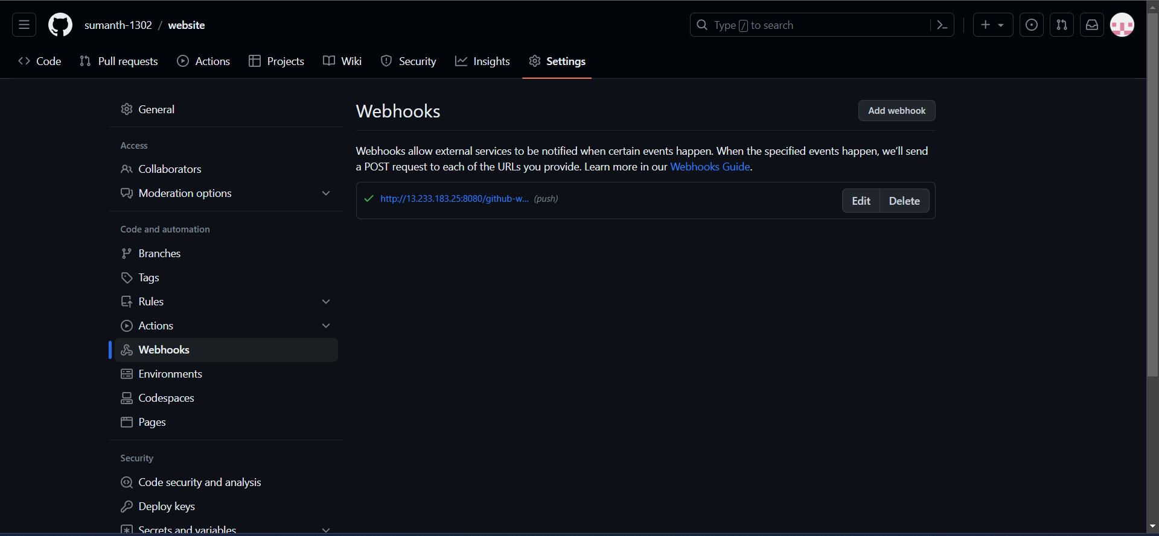

* Wrote script to create a container with ubuntu and Apache installed in it and used the container to build the code which is in ‘/var/www/html’

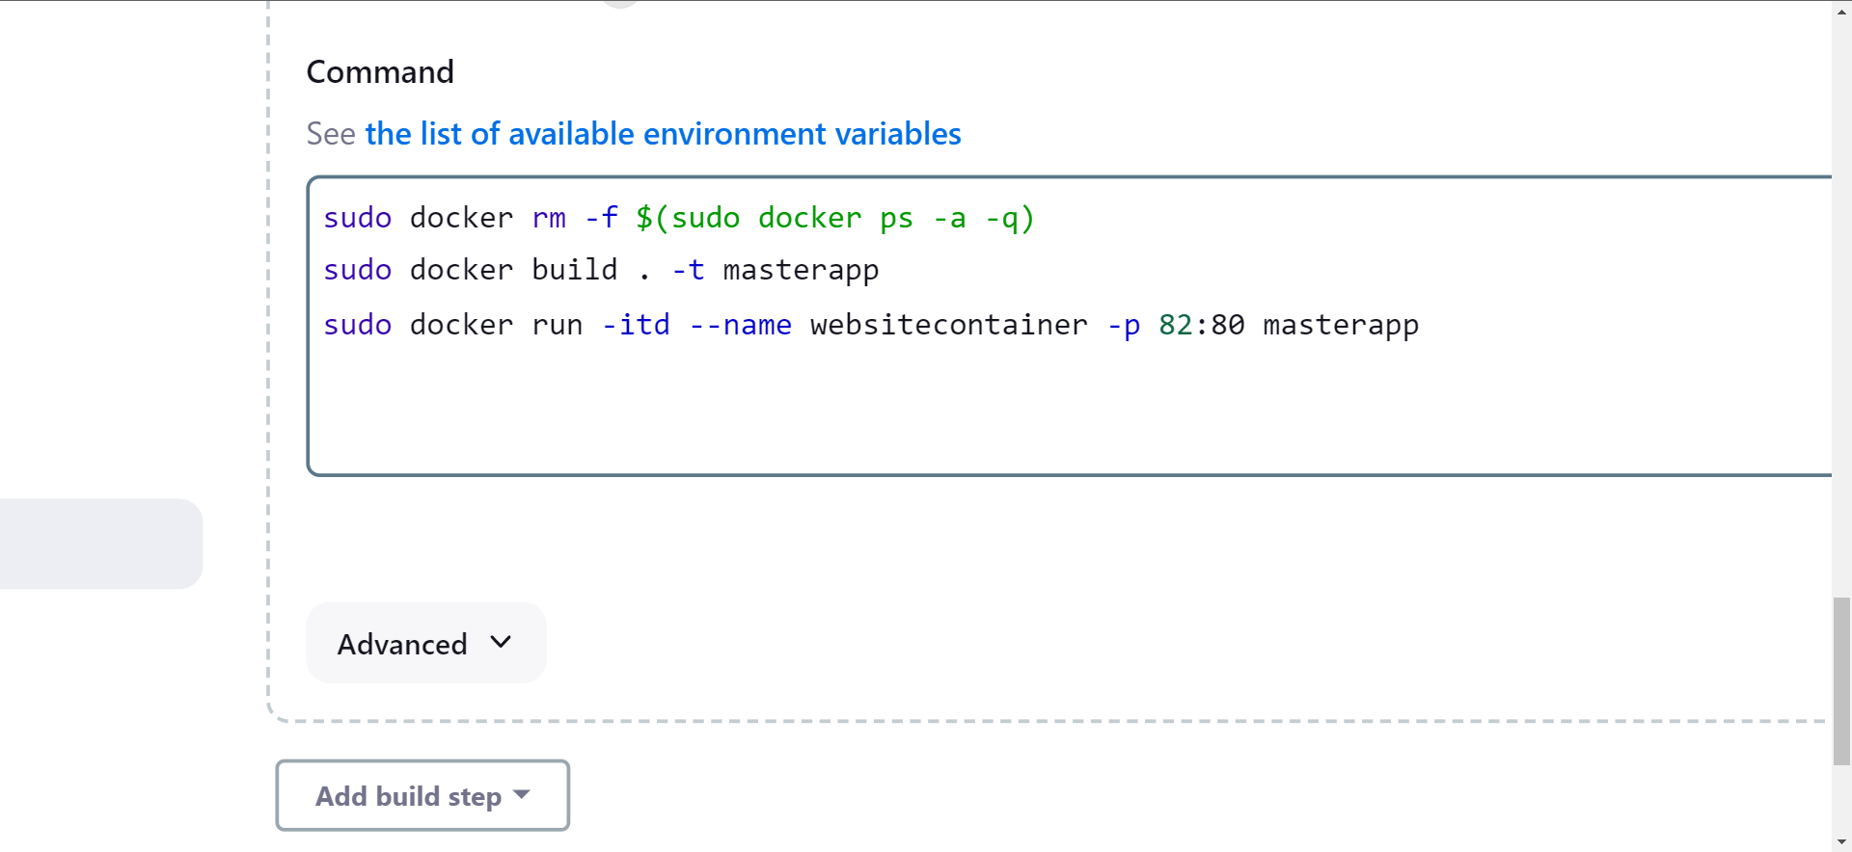

* Published a website on port 82

